Q1:

|  |  |  |  |  |
| --- | --- | --- | --- | --- |
| IP | Valid/invalid | Class | Public/private | Reserved/not-reserved |
| 107.17.17.17 | valid | A | PUBLIC | Not-reserved |
| 34.34.34.34 | valid | A | PUBLIC | Not-reserved |
| 51.51.51.1 | valid | A | PUBLIC | Not-reserved |
| 68.68.68.18 | valid | A | PUBLIC | Not-reserved |
| 85.85.85.35 | valid | A | PUBLIC | Not-reserved |

Q3:

Task-1:Route

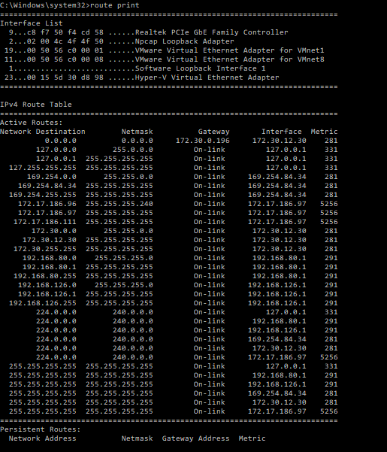

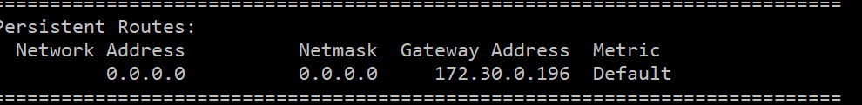

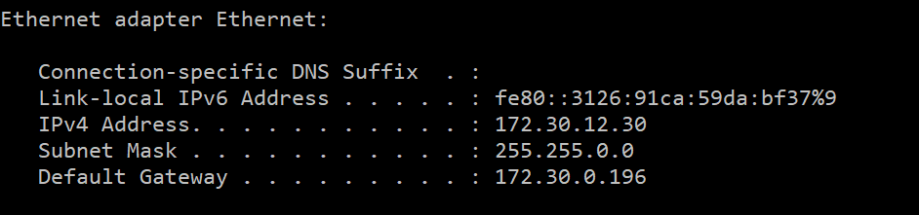



**TASK-2: NETSH**

**Using NETSH command Display and Save the following:**

1. **Information about Network IP configuration**

netsh interface ip dump > current-interfaces.txt

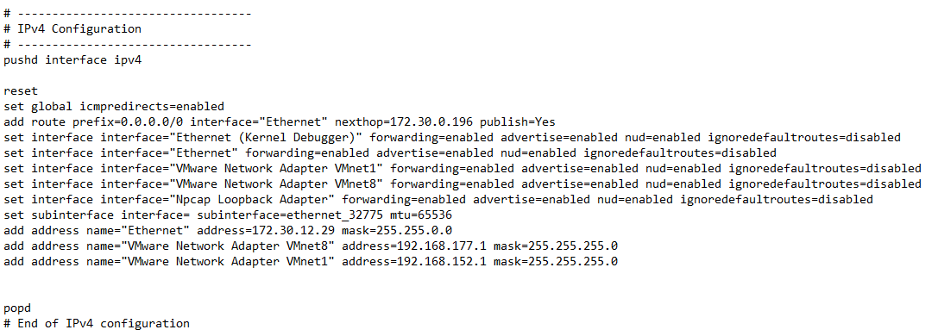

1. **Information about all TCP Connections**



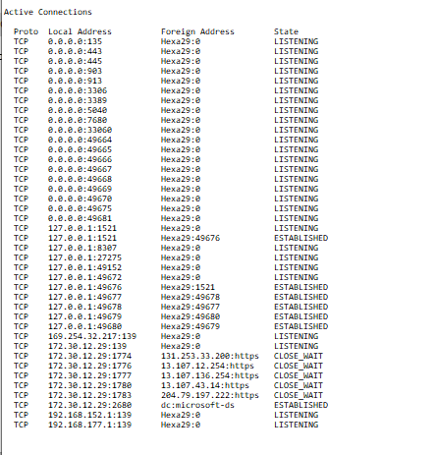

1. **Information about all UDP Connections**



Q2:

